

**APPLIED PHYSICS LAB**

**Lab Report: To ﬁnd the Temperature coefﬁcient of Resistance of a Coil using Wheatstone Bridge**

**Submitted To:**

Sir. Haseen Ullah Jan

**Submitted By:**

Ali Asghar

Section C

Registration No. 21PWCSE2059

Department Of Computer Systems Engineering

Fall 2021

**INTRODUCTION & BACKGROUND**

Temperature coefﬁcient of resistance is the measure of change in electrical resistance of any substance per degree of temperature change. Let us take a conductor having a resistance of R0 at 0oC and Rt at toC respectively. This αo is called temperature coefﬁcient of resistance of that substance at 0oC.

# APPARATUS:

Following apparatus is used to carry out this demonstration:

1. Coil
2. Water
3. Keys
4. Thermometer
5. Wheatstone Bridge
6. H.R.B
7. Galvanometer

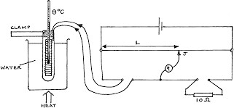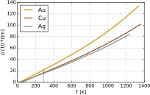

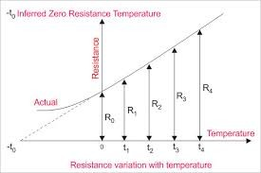

# PROCEDURE:

Following procedure is needed to be followed:

1. First of all connections of galvanometer and whole apparatus. Then the deﬂection of galvanometer is read as maximum.
2. Some of resistance is plugged out of P and Q noting that P>Q to bring deﬂection on scale.
3. Resistance is decreased or increased to bring galvanometer to zero point.
4. Value of temperature T1 is taken and Rt is calculated by the formula given below;

R= *Q x R*

*P*

1. Then the water is boiled and Rt2 is calculated.
2. Value of temperature is noted.

# READINGS:

|  |  |  |  |  |  |  |  |  |
| --- | --- | --- | --- | --- | --- | --- | --- | --- |
| S.No | T1 | T2 | P in ohms | Q in Ohms | R in Ohms | Rt1=  *Q x R P* | Rt2=  *Q x R P* | α=  *Rt*2−*Rt*1  *Rt*1(*t*1)−*Rt*2(*t*10 |
| 1. | 40 | 70 | 1000 | 100 | 200 | 20 | 22 | 2/50=0.003  8 |
| 2. | 60 | 80 | 100 | 10 | 210 | 21 | 22.5 | 2.5/435=0.  0057 |
| 3. | 32 | 85 | 1000 | 10 | 900 | 9 | 11.19 | 2.19/379.9  2=0.00576 |
| 4. | 42 | 56 | 1000 | 100 | 205 | 20.5 | 23 | 2.5/601=0.  0041 |